Instructions to establish secured tunnel between client and server using SSH tunneling

- On the Host Server perform the following
  - Install “Open SSH Server” from Settings > Optional Features
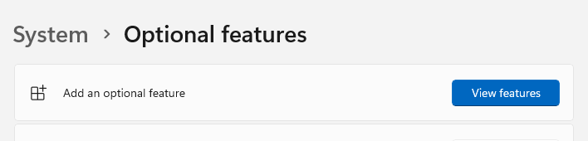
  - Go to “Services”
    - Ensure that the service is set to “Automatic”
    - Ensure that the service is running properly.
    - Note: this server is very sensitive to any change in files or folders security settings or permissions.. cannot modify any permission of any file in the folder “C:\ProgramData\ssh”.
  - Open Text Editor in Administrative mode and open the file “C:\ProgramData\ssh\sshd_config”. Modify the following configurations
ListenAddress 0.0.0.0
#HostKey __PROGRAMDATA__/ssh/ssh_host_ed25519_key
PubkeyAuthentication yes
PasswordAuthentication yes
PermitEmptyPasswords no
AllowTcpForwarding yes
GatewayPorts no
PermitTunnel yes
AuthorizedKeysFile .ssh/authorized_keys

  - Restart the service “Open SSH Server”
  - Ensure that the Port 22 (default SSH port) is allowed for inbound connections on the firewall
- On the Server-Router side
  - Ensure that the Port 22 on the Host Server has the proper forwarding to a public port (say 8822)
- On the client side
  - Download and install an SSH client. Say PuTTY
  - Configure PuTTY to connect to the SSH server at port 8822
(assume host server WAN IP Address is 112.254.13.59)
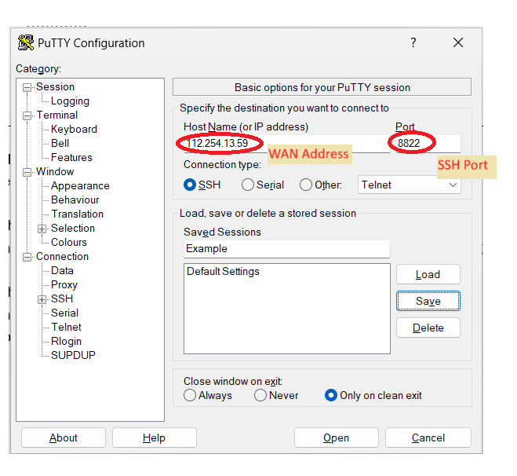

Go to SSH Tunnels Category in PuTTY Configuration panel. Add The local port mapping. For example, local port 3399 is mapped to 192.168.0.100:3389 (localhost since it is the same server where OpenSSH is installed). Also local port 444 is mapped to 192.168.0.100:443 (localhost:443)

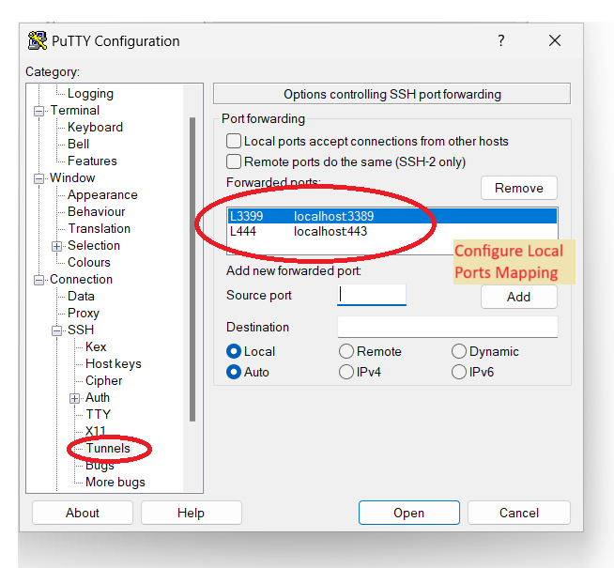

Don’t forget to save the settings so that you can use it next time
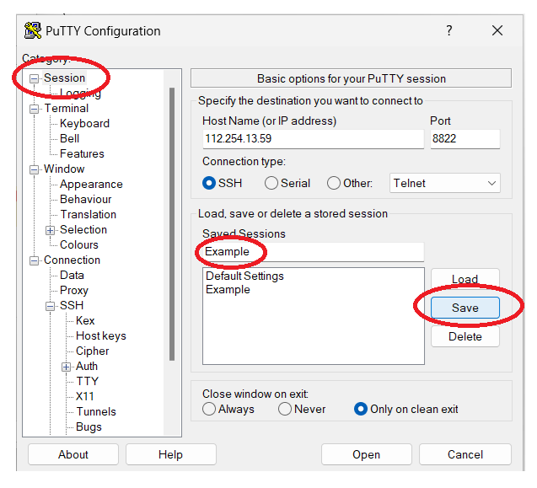

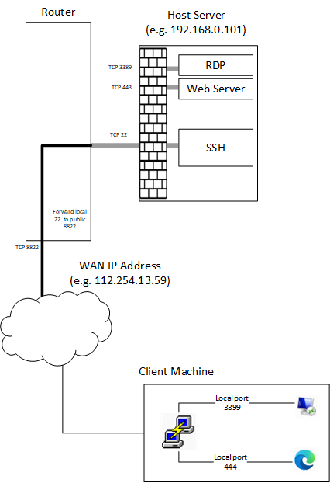

Now that the PuTTY client is configured, a tunnel can be created by “Open” a connection, enter credentials on the host server, and then you can use the tunnel to connect locally
- For RDP session to host server connect to localhost:3399
- For accessing website use https://localhost:444
- Other ports can be configured (mapped) to access any port on the remote network (192.168.0.*),

Public Key Authentication
PubkeyAuthentication is a server-side setting in the sshd_config file that controls whether SSH public key authentication is allowed.
How it works (simplified):
- You (the client) generate a key pair:
  - id_rsa (private key)
  - id_rsa.pub (public key)
- You copy the public key to the server and place it in:
makefile
CopyEdit
C:\Users\<username>\.ssh\authorized_keys
- When you SSH into the server, your client proves ownership of the private key without sending it.
- The server checks if your public key matches an entry in authorized_keys. If yes — access is granted.

